GSE Geometry Module 5
LO5.8 I can prove whether or not a specific point lies on a given circle.

Key Points:
Equation of a Circle: ${(x-h)}^{2}+{(y-k)}^{2}=r^{2}$

If $(x,y)$ is the center of a circle, it is used as $(h,k)$.
For example, a circle with a center at $(3,4)$ with a radius of 5 would be written as:
${(x-3)}^{2}+{(y-4)}^{2}=25$

Examples: Write the equation of the circle in standard form.
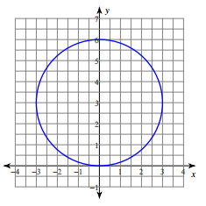
What is the center of the circle?

What is the radius?

The standard form of the equation for this circle is:

1. Find the equation of a circle whose diameter has endpoints $(4, -1)$ and $(-6, 7)$.

2. Determine if the point is on, inside, or outside the circle $x^{2}+y^{2}=45$. Explain your reasoning.
a. $(6, -3)$ b. $(-1, 7)$ c. $(-3, 5)$

3. Points $(a, 5)$ and $(9, b)$ are on the circle $x^{2}+y^{2}=125$. What are the values of $a$ and $b$?

Work Time:

