**Unit 4 Circles Review**

**Angles in Circles**

Write the formulas

* Central Angles: _____________________________________________________
* Inscribed Angles: ___________________________________________________
* Angles Inside the Circle: ____________________________________________

(not in the center)

* Angles Outside the Circle: __________________________________________

1) In the circle below, *C* is the center, and $m∠ACB=110°$. Find the following

measures.



$m\hat{AB}$ =

$m\hat{EB}$ ___________

=

$m\hat{EDB}$ ­___________

=

$m∠EDB$ __________

= ­­­­_________

Find the measure of the indicated angle or arc.



|  |  |
| --- | --- |
| 2) $m∠BAC=_________$ | 3) $m\hat{BC}=________$ |
| 4) z = _____________ | 5) x = ___________  28°  112°  x |
| $6) m∠P= _____________$ | 7) x = ________ |
| 8) x = ___________ | 9) x = ____________ |

10) ∠AED is formed inside a circle by two intersecting chords. If minor arc BD = 82 and minor arc CA = 176, what is the measure of ∠ AED?

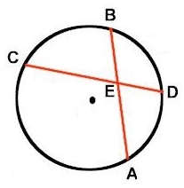10)

**Segment Lengths in Circles**

Write the formulas:

* Chords that intersect inside: ______________________________________________
* Secants that intersect outside: ____________________________________________
* Secant and Tangent that intersect outside: ________________________________

Find the indicated measure.

|  |  |
| --- | --- |
| 11) Find x. | 12) *DE* = 2x + 8, *EC* = 3*, AE* = 4x – 3*, and*  *EB* = 4. Find $m\overline{CD}$. |
| 13) Find x. | 14) Find x. |
| 15) Find the $m\overline{KM}$. | 16) Find the length of the top secant. |

17) In the diagram, segments AD and AB are tangent to circle C. Solve for x.

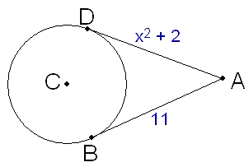

18) Quadrilateral ABCD is inscribed in the circle. If m∠A = 95°, what also must be true?

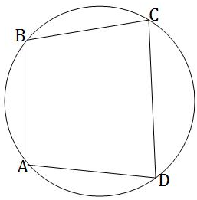

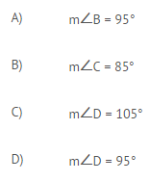

**Arc Length and Sector Area**

Write the formulas:

Circumference: ________________ Arc Length: ________________________

Area: ___________________ Sector Area: _______________________

Find the arc length and sector area of the following.

|  |  |
| --- | --- |
| 19)    Arc Length: _________  Sector Area: _________ | 20) central angle of 850 and a diameter  of 5 cm.  Arc Length: _______  Sector Area: _______ |
| 21. The diameter of a pie is 10 in. The pie is cut into 8 slices. What is the arc length of each slice? | 22. An Apple pie has a radius of 4.5in. The pie is cut into 6 equal pieces. What is the area of each piece of the pie? |

23. A sprinkler has a circular path that sprays 20 ft (the radius of the circle). If the sprinkler

is set to a quarter turn, what is the area of the yard that will be watered?

24. The radius of a bike wheel is 12 inches. There are 9 spokes on the wheel. What is the

length between each spoke?

25. There are two pies each with a diameter of 12 in. One pie is cut into 6 slices. The

other is cut into 10 slices. How much more pie do you get from a slice of the first pie?

26. A circular track has a diameter of 100 yards. A track athlete sprints around half the

track. How far did the athlete sprint?

27. The Cheesecake Factory has two different sizes of cheesecake. A small cheesecake

has a diameter of 8 inches and is cut into 8 slices. A large cheesecake has a

diameter of 12 inches and is cut into 12 slices. Which option would give you more

cheesecake; purchasing three slices of the small cheesecake or two slices of the

large cheesecake?

**Skateboarding has become a popular sport. The parks department is thinking of constructing ramps in some of the local playgrounds. A “half-pipe” ramp is formed by two quarter-circle ramps, each of which is 10 feet high, plus a flat space 20 feet long between the centers.**

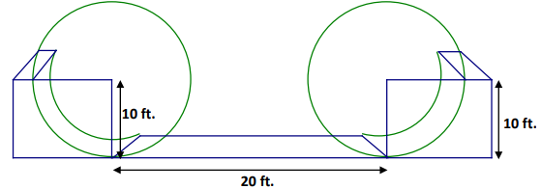

28. Find the distance a skater travels from the top of one ramp to the top of the other.

29. Another launch ramp is formed by 2 arcs, each with a central angle of 60 degrees and a radius of 10 ft. Find the length from the top of one ramp to the top of the other.