1. This table shows the names of students in Mr. Leary’s class who do or do not own bicycles and skateboards.
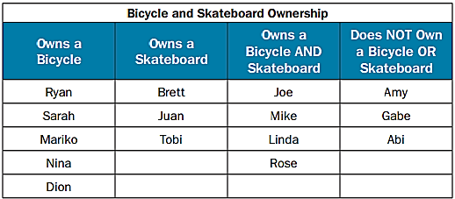
Let set A be the names of students who own bicycles, and let set B be the names of students who own skateboards.

a. Find A and B. What does the set represent?
b. Find A or B. What does the set represent?
c. Find (A or B)′. What does the set represent?

2. In a certain town, the probability that a person plays sports is 65%. The probability that a person is between the ages of 12 and 18 is 40%. The probability that a person plays sports and is between the ages of 12 and 18 is 25%. Are the events independent? How do you know?

3. A random survey was conducted to gather information about age and employment status. This table shows the data that were collected.
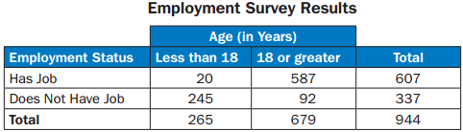
a. What is the probability that a randomly selected person surveyed has a job, given that the person is less than 18 years old?

b. What is the probability that a randomly selected person surveyed has a job, given that the person is greater than or equal to 18 years old?

c. Are having a job (A) and being 18 or greater (B) independent events? Explain.

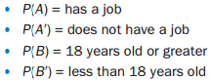

4. In a particular state, the first character on a license plate is always a letter. The last character is always a digit from 0 to 9. If V represents the set of all license plates beginning with a vowel, and O represents the set of all license plates that end with an odd number, which license plate belongs to the set V and O′ ?
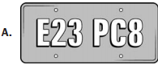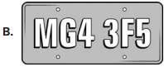
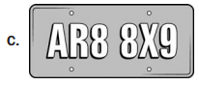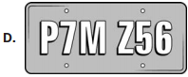

5. For which set of probabilities would events A and B be independent?

A. P(A) = 0.25; P(B) = 0.25; P(A and B) = 0.5
B. P(A) = 0.08; P(B) = 0.4; P(A and B) = 0.12
C. P(A) = 0.16; P(B) = 0.24; P(A and B) = 0.32
D. P(A) = 0.3; P(B) = 0.15; P(A and B) = 0.045

6. Assume that the following events are independent:
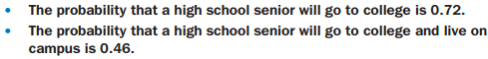
What is the probability that a high school senior will live on campus, given that the person will go to college?
A. 0.26 B. 0.33 C. 0.57 D. 0.64

7. A random survey was conducted about gender and hair color. This table records the data.
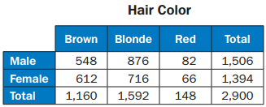
What is the probability that a randomly selected person has blonde hair, given that the person selected is male?
A. 0.51 B. 0.55 C. 0.58 D. 0.63

8. In Mr. Mabry’s class, there are 12 boys and 16 girls. On Monday, 4 boys and 5 girls were wearing white shirts.

a. If a student is chosen at random from Mr. Mabry’s class, what is the probability of choosing a boy or a student wearing a white shirt?

b. If a student is chosen at random from Mr. Mabry’s class, what is the probability of choosing a girl or a student not wearing a white shirt?

9. Terry has a number cube with sides labeled 1 through 6. He rolls the number cube twice.

a. What is the probability that the sum of the two rolls is a prime number, given that at least one of the rolls is a 3?

b. What is the probability that the sum of the two rolls is a prime number or at least one of the rolls is a 3?

10. Mrs. Klein surveyed 240 men and 285 women about their vehicles. Of those surveyed, 155 men and 70 women said they own a red vehicle. If a person is chosen at random from those surveyed, what is the probability of choosing a woman or a person who does NOT own a red vehicle?
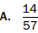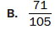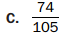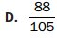

11. Bianca spins two spinners that have four equal sections numbered 1 through 4. If she spins a 4 on at least one spin, what is the probability that the sum of her two spins is an odd number?

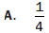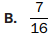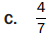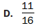

12. Each letter of the alphabet is written on separate cards in red ink. The cards are placed in a container. Each letter of the alphabet is also written on separate cards in black ink. The cards are placed in the same container. What is the probability that a card randomly selected from the container has a letter written in black ink or the letter is A or Z?
