1. A city has a population of 6,688 people. The area of the city is approximately 7.267 square miles. How many people per square mile live in the city?

2. This is a hand drawing of a mountain.
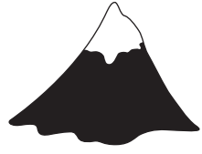
Explain which geometric shape could be used to estimate the total amount of Earth the mountain is made of.

3. A construction company is preparing 10 acres of land for a new housing community. The land contains large rocks that need to be removed. A machine removes 10 rocks from 360 square feet of land.
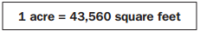
About how many rocks will need to be removed from the 10 acres of land?

4. A company needs to package this bell in a rectangular box.
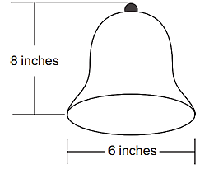
What are the smallest dimensions (length, width, and height) the rectangular box can have so that the lid of the box can also close?

5. Joe counts 250 peach trees on 25% of the land he owns. He determined that there are 10 trees for every 1,000 square feet of land. About how many acres of land does Joe own?
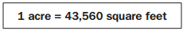

A. 2.3 acres B. 10 acres C. 43.56 acres D. 2,500 acres
6. A square pyramid is packaged inside a box.
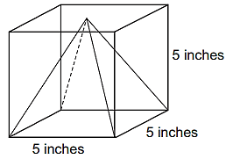
The space inside the box around the pyramid is then filled with protective foam. About how many cubic inches of foam is needed to fill the space around the pyramid?

A. 8 cubic inches B. 41 cubic inches C. 83 cubic inches D. 125 cubic inches

7. What is the equation of the circle with a center at (4, 5) and a radius of 2?
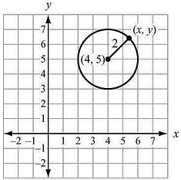

8. What is the center and radius of the circle given by $8x^{2} + 8y^{2} – 16x – 32y + 24 = 0$?

9. Which is an equation for the circle with a center at (–2, 3) and a radius of 3?

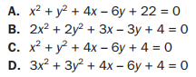

10. What is the center of the circle given by the equation $x^{2} +{ y}^{2} – 10x – 11 = 0$?

A. (5, 0) B. (0, 5) C. (–5, 0) D. (0, –5)

11. Quadrilateral ABCD has vertices A(–1, 3), B(3, 5), C(4, 3), and D(0, 1). Is ABCD a rectangle? Explain how you know.

12. Circle C has a center of (–2, 3) and a radius of 4. Does point (–4, 6) lie on circle C?

13. The line p is represented by the equation $y = 4x + 1$. What is the equation of the line that is perpendicular to line p and passes through the point (8, 5)?

14. For what value of n are the lines $7x + 3y = 8$ and $nx + 3y = 8$ perpendicular?

15. Quadrilateral ABCD has vertices A(4, 0), B(3, 3), C(–3, 1), and D(–2, –2). Prove that ABCD is a rectangle.

16. Given the points A(–1, 2) and B(7, 8), find the coordinates of the point P on directed line segment $\overline{AB}$ that partitions $\overline{AB}$ in the ratio 1:3.

17. Find the area of rectangle ABCD with vertices A(–3, 0), B(3, 2), C(4, –1), and D(–2, –3).

18. Which information is needed to show that a parallelogram is a rectangle?

A. The diagonals bisect each other. B. The diagonals are congruent.

C. The diagonals are congruent and perpendicular. D. The diagonals bisect each other and are perpendicular.

19. Which point is on a circle with a center of (3, –9) and a radius of 5?

A. (–6, 5) B. (–1, 6) C. (1, 6) D. (6, –5)

20. Given the points P(2, –1) and Q(–9, –6), what are the coordinates of the point on directed line segment $\overline{PQ}$ that partitions $\overline{PQ}$ in the ratio $\frac{3}{2}$ ?
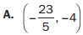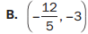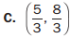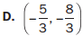

21. An equation of line a is $y= – \frac{1}{2} x – 2$.
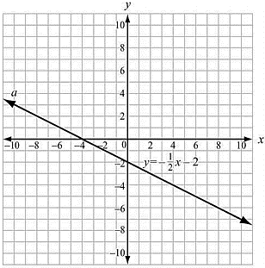
Which is an equation of the line that is perpendicular to line a and passes through the point
(–4, 0)?
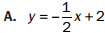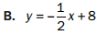

22. Parallelogram ABCD has vertices as shown.
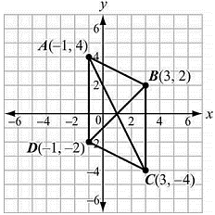
Which equation would be used in proving that the diagonals of parallelogram ABCD bisect each other?
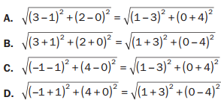

23. Triangle ABC has vertices as shown.
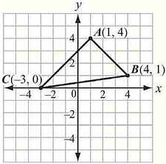

What is the area of the triangle?

23. Look at quadrilateral ABCD.
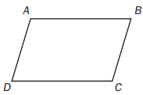
Which information is needed to show that quadrilateral ABCD is a parallelogram?
A. Use the distance formula to show that diagonals AC and BD have the same length.
B. Use the slope formula to show that segments AB and CD are perpendicular and segments AD and BC are perpendicular.
C. Use the slope formula to show that segments AB and CD have the same slope and segments AD and BC have the same slope.
D. Use the distance formula to show that segments AB and AD have the same length and segments CD and BC have the same length.

