1. ∠PNQ is inscribed in circle O and $m\hat{PQ} = 70°.$
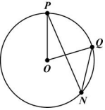
a. What is the measure of ∠POQ?

b. What is the relationship between ∠POQ and ∠PNQ?

c. What is the measure of ∠PNQ?

2. In circle P below, $\overline{AB}$ is a diameter.
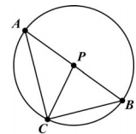
If $m∠APC = 100°$, find the following:

a. $m∠BPC$

b. $m∠BAC$

c. $m\hat{BC}$

d. $m\hat{AC}$

3. In circle P below, $\overline{DG}$ is a tangent. $\overline{AF}$ = 8, $\overline{EF}$ = 6, $\overline{BF}$ = 4, and $\overline{EG}$ = 8.
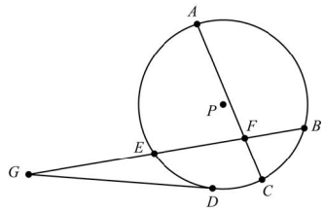
Find $\overline{CF}$ and $\overline{DG}$.

4. In this circle, $\overline{AB}$ is tangent to the circle at point B, $\overline{AC}$ is tangent to the circle at point C, and point D lies on the circle. What is $m∠BAC$?
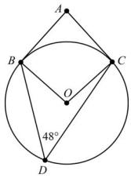

5. Circle P is dilated to form circle P′. Which statement is ALWAYS true?

A. The radius of circle P is equal to the radius of circle P′.

B. The length of any chord in circle P is greater than the length of any chord in circle P′.

C. The diameter of circle P is greater than the diameter of circle P′.

D. The ratio of the diameter to the circumference is the same for both circles.

6. In the circle shown, $\overline{BC}$ is a diameter and $m\hat{AB} = 120°$.
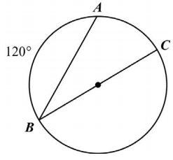
What is the measure of ∠ABC?

A. 15° B. 30° C. 60° D. 120°

7. Circles A, B, and C have a central angle measuring 100°. The length of each radius and the length of each intercepted arc are shown.
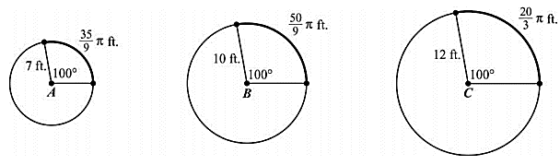
a. What is the ratio of the radius of circle B to the radius of circle A?

b. What is the ratio of the length of the intercepted arc of circle B to the length of the intercepted arc of circle A?

c. Compare the ratios in parts (a) and (b).

d. What is the ratio of the radius of circle C to the radius of circle B?

e. What is the ratio of the length of the intercepted arc of circle C to the length of the intercepted arc of circle B?

f. Compare the ratios in parts (d) and (e).

g. Based on your observations of circles A, B, and C, what conjecture can you make about the length of the arc intercepted by a central angle and the radius?

h. What is the ratio of arc length to radius for each circle?

8. 2. Circle A is shown.
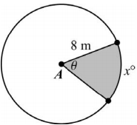
If x = 50, what is the area of the shaded sector of circle A?

9. Circle E is shown.
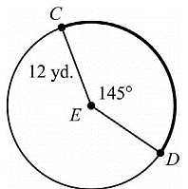
What is the length of $\hat{CD}$?
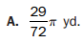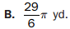
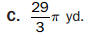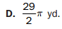

10. Circle Y is shown.
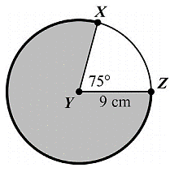
What is the area of the shaded part of the circle?
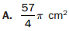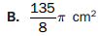
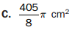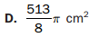

11. The spokes of a bicycle wheel form 10 congruent central angles. The diameter of the circle formed by the outer edge of the wheel is 18 inches.
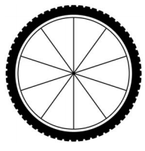
What is the length, to the nearest 0.1 inch, of the outer edge of the wheel between two consecutive spokes?

A. 1.8 inches B. 5.7 inches C. 11.3 inches D. 25.4 inches

Volume

12. What is the volume of the cone shown below?
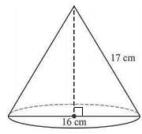

13. A sphere has a radius of 3 feet. What is the volume of the sphere?

14. A cylinder has a radius of 10 cm and a height of 9 cm. A cone has a radius of 10 cm and a height of 9 cm. Show that the volume of the cylinder is three times the volume of the cone.

15. Cylinder A and Cylinder B are shown below. What is the volume of each cylinder?
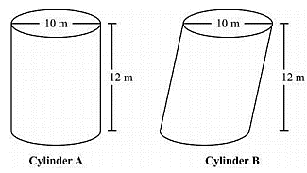

16. Jason constructed two cylinders using solid metal washers. The cylinders have the same height, but one of the cylinders is slanted as shown. Which statement is true about Jason’s cylinders?
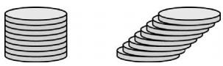
A. The cylinders have different volumes because they have different radii.
B. The cylinders have different volumes because they have different surface areas.
C. The cylinders have the same volume because each of the washers has the same height.
D. The cylinders have the same volume because they have the same cross-sectional area at every plane parallel to the bases.

17. What is the volume of a cylinder with a radius of 3 in. and a height of $\frac{9}{2}$ in.?

