1. Triangles ABC and DEF are similar.
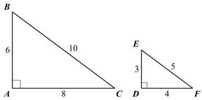
a. Find the ratio of the side opposite angle B to the hypotenuse in △ABC.

b. What angle in △DEF corresponds to angle B?

c. Find the ratio of the side opposite angle E to the hypotenuse in △DEF.

d. How does the ratio in part (a) compare to the ratio in part (c)?

e. Which trigonometric ratio does this represent?

2. Ricardo is standing 75 feet away from the base of a building. The angle of elevation from the ground where Ricardo is standing to the top of the building is 32°.
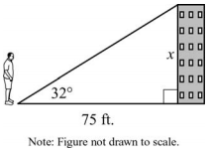
What is x, the height of the building, to the nearest tenth of a foot?

3. An airplane is at an altitude of 5,900 feet. The airplane descends at an angle of 3°.
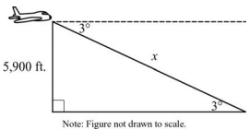
About how far will the airplane travel in the air until it reaches the ground?

4. Triangle ABC is a right triangle.
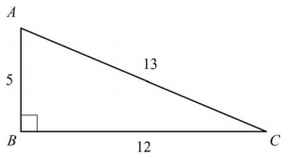
What is the best approximation for m∠C?

5. In right triangle ABC, angle A and angle B are complementary angles. The value of cos A is $\frac{5}{13}$. What is the value of sin B?

A. $\frac{5}{13}$ B. $\frac{12}{13}$

C. $\frac{13}{12}$ D. $\frac{13}{5}$

6. Triangle ABC is given below.
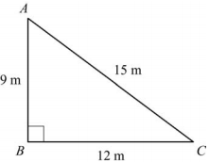
What is the value of cos A?

A. $\frac{3}{5}$ B. $\frac{3}{4}$

C. $\frac{4}{5}$ D. $\frac{5}{3}$

7. In right triangle HJK, ∠J is a right angle and tan ∠H = 1. Which statement about triangle HJK must be true?

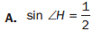

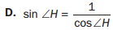

8. A 12-foot ladder is leaning against a building at a 75° angle with the ground.
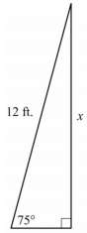
Which equation can be used to find how high the ladder reaches up the side of the building?

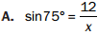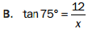

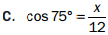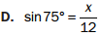

9. A hot air balloon is 1,200 feet above the ground. The angle of depression from the basket of the hot air balloon to the base of a monument is 54°.
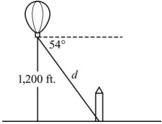
Which equation can be used to find the distance, d, in feet, from the basket of the hot air balloon to the base of the monument?

