1. Draw a triangle with vertices at A(0, 1), B(–3, 3), and C(1, 3). Dilate the triangle using a scale factor of 1.5 and a center of (0, 0). Sketch and name the dilated triangle A'B'C'.
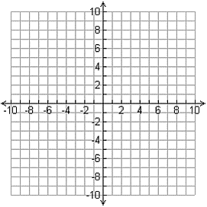

2. Line segment $\overline{CD}$ is 5 inches long. If line segment $\overline{CD}$ is dilated to form line segment $\overline{C'D'}$ with a scale factor of 0.6, what is the length of line segment $\overline{C'D'}$?

3. Figure A′B′C′D′ is a dilation of figure ABCD.
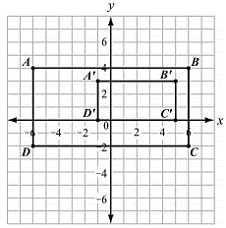

a. Determine the center of dilation.

b. Determine the scale factor of the dilation.

c. What is the relationship between the sides of the pre-image and the corresponding sides of the image?

4. Which transformation results in a figure that is similar to the original figure but has a greater area?

A. a dilation of △QRS by a scale factor of 0.25 B. a dilation of △QRS by a scale factor of 0.5

C. a dilation of △QRS by a scale factor of 1 D. a dilation of △QRS by a scale factor of 2
5. Figure A′B′C′D′F′ is a dilation of figure ABCDF by a scale factor of $\frac{1}{2}$ . The dilation is centered at (–4, –1).
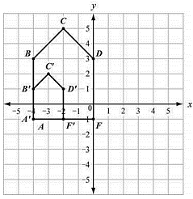
Which statement is true?

A. 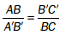 B. 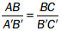

C. 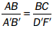 D. 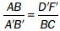

6. In the coordinate plane, segment $\overline{PQ}$ is the result of a dilation of segment $\overline{XY}$ by a scale factor of $\frac{1}{2}$ .
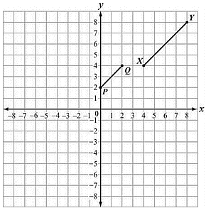
Which point is the center of dilation?

A. (–4, 0) B. (0, –4) C. (0, 4) D. (4, 0)

7. Consider the triangles shown.
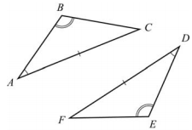
Which can be used to prove the triangles are congruent?

A. SSS B. ASA C. SAS D. AAS
8. In the triangle shown, $\overline{AC} ||\overline{ DE}$.
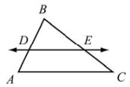
Prove that $\overline{DE}$ divides $\overline{AB}$ and $\overline{CB}$ proportionally.
Fill in the missing reasons.

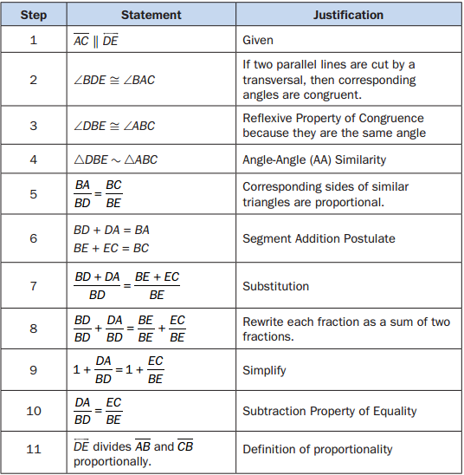

9. In the triangles shown, △ABC is dilated by a factor of $\frac{2}{3}$ to form △XYZ. Given that m∠A = 50° and m∠B = 100°, what is m∠Z?
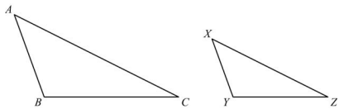

A. 15° B. 25° C. 30° D. 50°

10. In the triangle shown, $\overline{GH} ǁ \overline{DF}$.

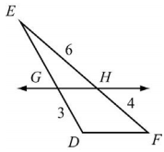

What is the length of $\overline{GE}$ ?

A. 2.0 B. 4.5 C. 7.5 D. 8.0

11. Use this triangle to answer the question.
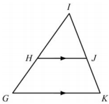
This is a proof of the statement “If a line is parallel to one side of a triangle and intersects the other two sides at distinct points, then it separates these sides into segments of proportional lengths.”
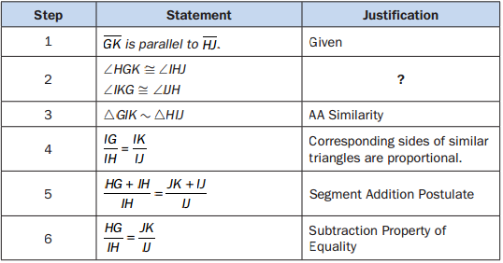
Which reason justifies Step 2?

A. Alternate interior angles are congruent.

B. Alternate exterior angles are congruent.

C. Corresponding angles are congruent.

D. Vertical angles are congruent.

12. Quadrilateral ABCD has vertices A(–1, 3), B(3, 5), C(4, 3), and D(0, 1). Is ABCD a rectangle? Explain how you know.

13. Is △ABC congruent to △MNP? Explain.
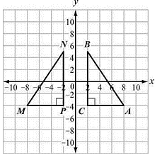
(scale unit = 2)

14. Rectangle WXYZ has coordinates W(1, 2), X(3, 2), Y(3, –3), and Z(1, –3).

a. Graph the image of rectangle WXYZ after a rotation of 90° clockwise about the origin. Label the image W′X′Y′Z′.

b. Translate rectangle W′X′Y′Z′ 2 units left and 3 units up.

c. Is rectangle WXYZ congruent to rectangle W″X″Y″Z″ ? Explain.

15. Parallelogram FGHJ was translated 3 units down to form parallelogram F′G′H′J′. Parallelogram F′G′H′J′ was then rotated 90° counterclockwise about point G′ to obtain parallelogram F″G″H″J″.
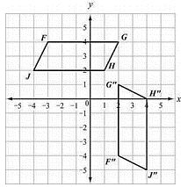
Which statement is true about parallelogram FGHJ and parallelogram F″G″H″J″?

A. The figures are both similar and congruent.
B. The figures are neither similar nor congruent.
C. The figures are similar but not congruent.
D. The figures are congruent but not similar.

16. In this diagram, DE ≅ JI and ∠D ≅ ∠J.
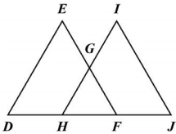
Which additional information is sufficient to prove that △DEF is congruent to △JIH?

A. $\overline{ED} ≅ \overline{IH}$ B. $\overline{DH} ≅ \overline{JF}$ C. $\overline{HG}≅\overline{GI}$ D. $\overline{HF }≅\overline{ JF}$

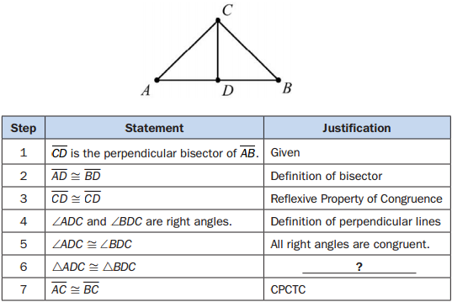
17. In this diagram, $\overline{CD}$ is the perpendicular bisector of $\overline{AB}$ . The two-column proof shows that $\overline{AC}$ is congruent to $\overline{BC}$ .

Which of the following would justify Step 6?

A. AAS B. ASA C. SAS D. SSS

18. In this diagram, STU is an isosceles triangle where $\overline{ST}$ is congruent to $\overline{UT}$ . The paragraph proof shows that ∠S is congruent to ∠U.
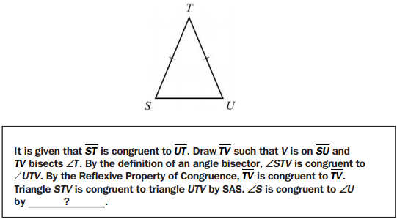
Which step is missing in the proof?

A. CPCTC B. Reflexive Property of Congruence

C. Definition of right angles D. Angle Congruence Postulate

