1. Draw the image of each figure, using the given transformation.

a. Use the translation (x, y) → (x – 3, y + 1). b. Reflect across the x-axis.
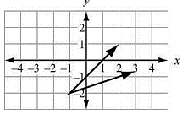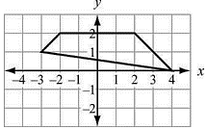

c. Reflect across the line y = x. d. Identify the vertices. The reflection image of each point (x, y) across the line y = –x is (–y, –x).
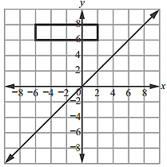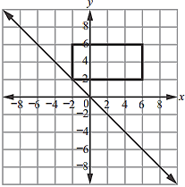

2. Specify a sequence of transformations that will map ABCD to PQRS in each case.

a. 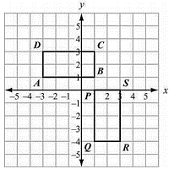 b. 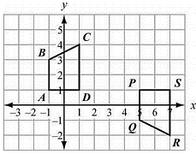

3. Describe every transformation that maps each given figure to itself.
a. 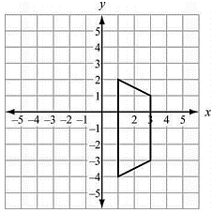 b. 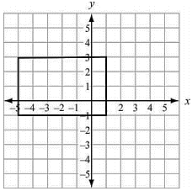

4. Describe every transformation that maps this figure to itself: a regular hexagon
(6 sides) that is centered about the origin and that has a vertex at (4, 0).

5. A regular pentagon is centered about the origin and has a vertex at (0, 4).
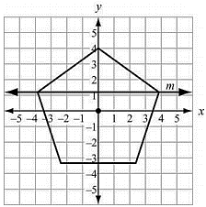
Which transformation maps the pentagon to itself?

A. a reflection across line m
B. a reflection across the x-axis
C. a clockwise rotation of 100° about the origin
D. a clockwise rotation of 144° about the origin

6. A parallelogram has vertices at (0, 0),
(0, 6), (4, 4), and (4, –2).
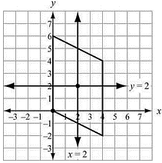
Which transformation maps the parallelogram to itself?

A. a reflection across the line x = 2
B. a reflection across the line y = 2
C. a rotation of 180° about the point (2, 2) D. a rotation of 180° about the point (0, 0)

7. Which sequence of transformations maps ▵ABC to ▵RST?
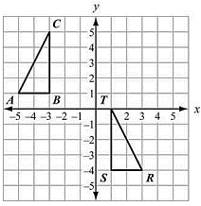
A. Reflect ▵ABC across the line x = –1. Then translate the result 1 unit down.

B. Reflect ▵ABC across the line x = –1. Then translate the result 5 units down.

C. Translate ▵ABC 6 units to the right. Then rotate the result 90° clockwise about the point (1, 1).

D. Translate ▵ABC 6 units to the right. Then rotate the result 90° counterclockwise about the point (1, 1).

