Name: ________________________________________________ Date: _______________________

Lunch Lines – Part 1 – Vertical Angles and Linear Pairs

If two angles share a vertex and together they make a straight angle, then the two angles are called a linear pair.

Practice Problems:
Find the missing angle.
1) 2) 3)

155ᵒ
60ᵒ
35ᵒ

Solve for x.
4) 5)
2x
x+30
2x + 10
70ᵒ

6) Linear pairs could be defined as being supplementary angles because they always add up to 180º. Are all supplementary angles linear pairs? Explain.

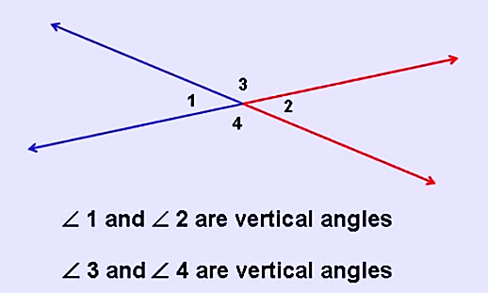
Two angles are vertical angles if their sides form two pairs of opposite rays and they share a common vertex.

How do you know that vertical angles are congruent?

m∠1 + m∠3 = 180° because of the Linear Pair postulate
m∠2 + m∠3 = 180° because of the Linear Pair postulate

Set the two equations equal to each other since they both equal 180 degrees.

m∠2 + m∠3 = m∠1 + m∠3 Can you think of another way to prove it?
$-$m∠3 $-$m∠3
m∠2 = m∠1

Therefore: ∠2 $≅$∠1

Prove that ∠3 $≅$∠4 using a similar method.

Practice Problems: Solve for the missing variable(s).

- 2)
xᵒ
130ᵒ
yᵒ
122ᵒ
(x – 12)ᵒ
zᵒ

3) 4)

105ᵒ
(x + 55)ᵒ
(2x + 5)ᵒ
(2x – 17)ᵒ

5)
(119 – x)ᵒ

(3x + 11)ᵒ

