Name: ________________________________________________ Date: _______________________

**Complementary and Supplementary Angles – Notes**

**TYPES OF ANGLES:** Sketch:

1. Acute: Acute angles have measures between 0° and 90°.
2. Right: A right angle has measure equal to 90°.
3. Obtuse: Obtuse angles have measures between 90° and 180°.

**SPECIAL PAIRS OF ANGLES:**

1. Complementary Angles: Pair of angles whose sum of measures equals 90°.

40° and 50° angles are complementary angles because 40° + 50° = 90°.

Example: A 40° angle is called the complement of the 50° angle.

Similarly, the 50° angle is the complement of the 40° angle.

**Practice**: Find the **complement** of each angle.

1. 35° b) 48° c) 12°
2. Supplementary Angle: Pair of angles whose sum of measures equals 180°.

60° and 120° angles are complementary angles because 60° + 120° = 180°.

Example: A 60° angle is called the supplement of the 120° angle.

Similarly, the 120° angle is the supplement of the 60° angle.

**Practice**: Find the **supplement** of each angle.

1. 40° b) 126° c) 72°

Can you think of a way to remember the difference between complementary and supplementary angles?

1. Angle Bisector: A ray (or line or segment) that divides an angle into two congruent angles (two angles with equal measure).

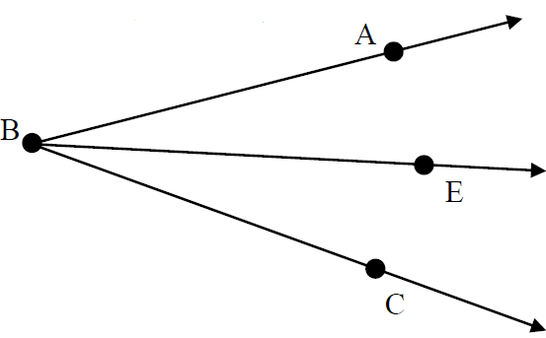

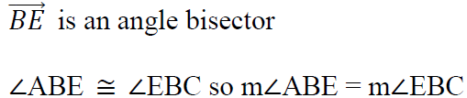

**Practice:**

1. Can two supplementary angles both be obtuse angles? Acute angles? Why?
2. Can two supplementary angles both be right angles? Why?
3. Refer to the diagram to answer each.  is an angle bisector.



1. If m∠ABE = 40°, find m∠EBC.
2. If m∠ABC = 70, find m∠ABE.
3. and are complementary. Solve for x and the measure of both angles.



1. and are complementary. Solve for x and the measure of both angles.



1. One of two complementary angles is 16 degrees less than its complement. Find the measure of both angles.
2. One of two complementary angles is 36° greater than its complement. Find the measure of both angles.
3. One of two complementary angles is 57° greater than twice its complement. Find the measure of both angles.
4. One of two supplementary angles is 98° greater than its supplement. Find the measure of both angles.
5. One of two supplementary angles is 123° less than twice its supplement. Find the measure of both angles.